Children’s outdoor trail – Answers

- 265 years ago
- The herbs were used for cooking, medicines, to smell nice (perfumes) and to chase away bugs and insects!
- This is the back of the house. People travelled by horse and carriage which they could not have got round to here. The ‘best’ side of the house needed to face the street. The big window gives light to the stairs and has a wonderful view of the Cathedral and the garden.
- The sculpture was designed and made by Hannah Golding who lives in Lichfield and went to school here. It shows the shape of Nautilus shells as Darwin believed that everything came from shells.

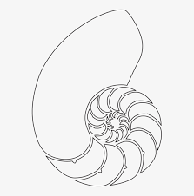

- The building was the stables. Darwin travelled to see his patients in a carriage pulled by his horse, who he called ‘Doctor.’ The horse needed stabling
- The cellars are behind the green door. Here you will find the remains of the kitchens, the wine cellars, bread ovens and the big open fireplaces they used for all the cooking and heating water for the laundry. There is also the housekeeper’s room where she slept to keep an eye on all the food and drink! It is cold and damp now but in Darwin’s time it would have been unbearably hot and smokey and no doubt riddled with vermin!
- The front door used to be approached via a highly decorated wooden bridge over a ditch or dimble, filled with water which ran round the front of the house and was part of the Cathedral’s defences.
It was the wealthy patients who arrived to see the doctor over the bridge. Erasmus often visited the poor in their homes. He was rather overweight and would ask a servant to go upstairs in these homes first, to test the strength of the floorboards. He needed to know they would take his weight!
- Dr. Darwin
His interests can be found on the stone slabs

We hope you’ve all learned a little about Erasmus Darwin on your trail Thank you all for coming.

