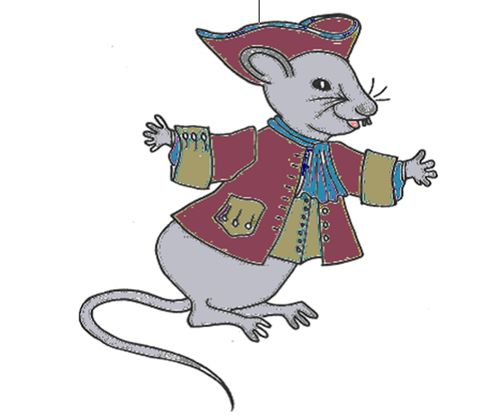
I am Dr Erasmouse.
Can you find my family – they are hiding in the house.
Dr Erasmouse is usually in the Lunar room. He looks after the mice in Lichfield when they are ill. He sneaks in to watch Erasmus meet his friends on the night of the full moon.
Francis is the son of Dr Erasmouse. He plays hide and seek in the Exhibition room. Can you find where he is hiding today
Polly is the wife of Dr Erasmouse. She often sits in the parlour with her sewing. She has lost her thimble – can you find it?
Robert Erasmouse is visiting from his home with Josiah Wedgwood. He likes to watch the narrowboats on the canal lift in the Inventions room.
Mary Erasmouse is the housekeeper. She can be spotted dusting the study.
The mice live in the cellar. They come up through their special door in the hallway. Can you spot it.
Tom Erasmouse lives in the stable outside with the horse. He likes to watch from the window as the visitors arrive. Can you spot him? Is the horse in the stable today?

