Newsletter3

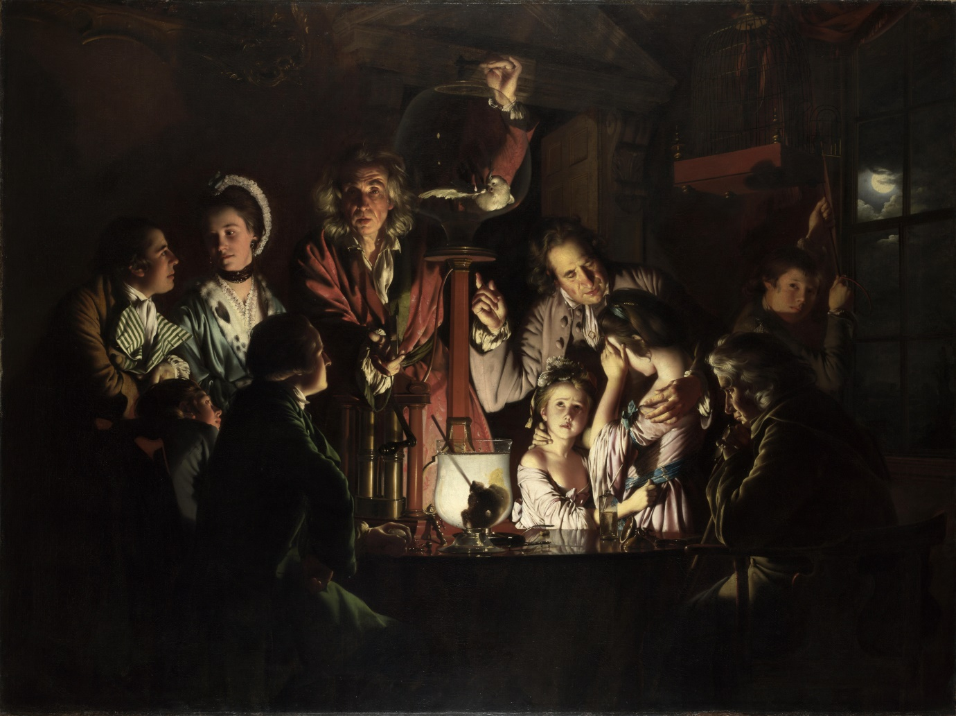

Do your Science lessons at school look like this?

What experiment might the ‘teacher’ be demonstrating?

Who are the ‘pupils’ watching and what are their reactions?

This is ‘The experiment on a bird in the air pump’ painted by Joseph Wright in 1768.

Sometimes, in the middle of the 18th century, scientists travelled around the country putting on demonstrations to the public or to invited groups, of scientific ideas, apparatus or effects.

In this case the lecturer was using an air pump to suck the air out of the big glass bowl. The cockatoo in the bowl would obviously struggle to breathe and eventually die – the two girls in the picture look upset while the others seem interested or unmoved. In fact, it’s likely that soon afterwards the air would be let back in and the bird revived.

But the idea was to create excitement with dramatic lighting and disturbing surroundings, and Wright made it even more dramatic in his detailed painting.

Joseph Wright knew many of the ‘Lunar group’ of inventors, doctors, scientists and industrialists, including Erasmus Darwin.

Darwin, grandfather of Charles Darwin, lived in Lichfield from 1756 to 1781 in the house in Beacon Street which is now a museum. He was a physician (or doctor) and treated patients from far and wide, including Wright who became his friend.

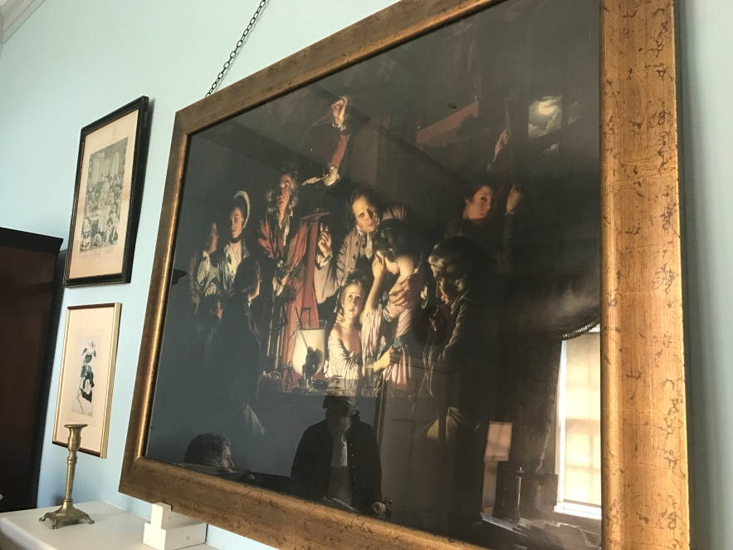This photo shows a reproduction of Wright’s painting in the study at Erasmus Darwin’s house, with a reflection of the figures of Darwin and Josiah Wedgewood in the glass. It’s a reminder that the two were friends although it wouldn’t have been there in Darwin’s lifetime. Some people think the man on the left of the painting, holding a stopwatch, is Dr Darwin himself, and the two boys his sons.

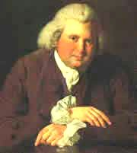The museum hopes to welcome you back again soon: meanwhile, let us know what you think of Wright’s painting!