**Activity 2**

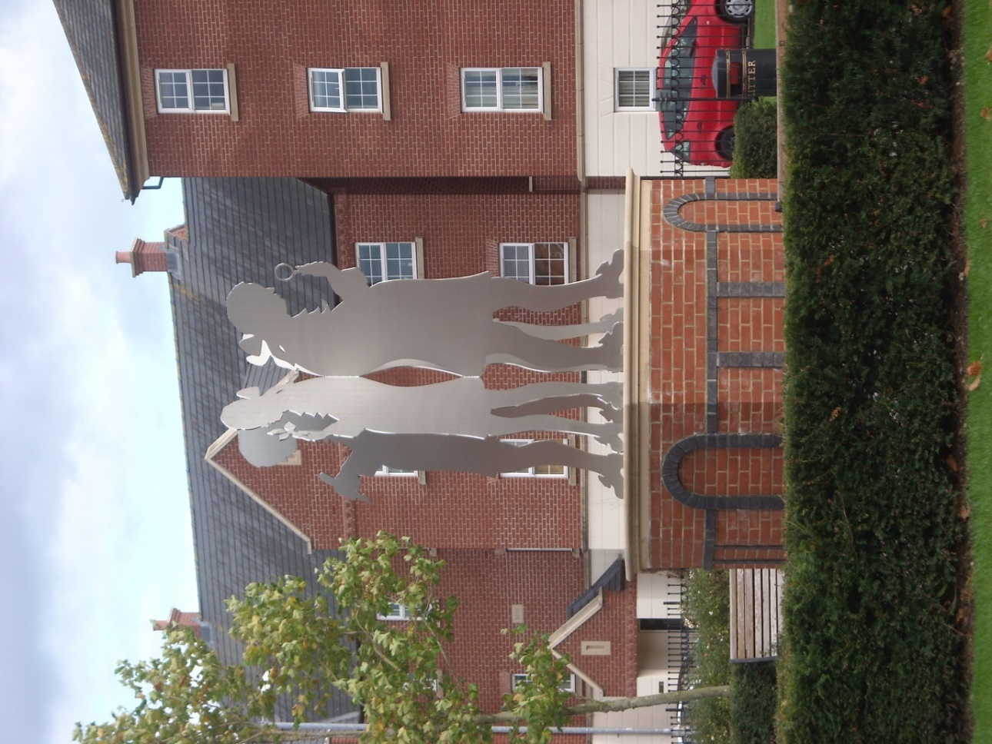

Have you seen this statue? Do you know who it is?

Take a look at his clothes, his shoes and his wig: how long ago might he have been alive?

And why are there four profiles the same, facing in different directions?

In fact this statue, standing in the centre of the Darwin Park estate, is of Erasmus Darwin. If you look closely you can see each Erasmus is holding a different object in his hand.

Darwin was a physician (or doctor) who lived and worked in Lichfield from 1756 to 1781. His home near the cathedral is now a museum which hopefully will reopen soon and you will be able to visit with your class or your family.

Darwin was very much in demand as a doctor, visiting patients all over the area and treating them with medicines or minor surgery.

Erasmus Darwin was also interested in plants and grew a great variety in his garden. He studied their structure, function and classification and used many as medicine, which was usual in those days. The herb garden behind his house is still looked after by volunteers and you can visit it.

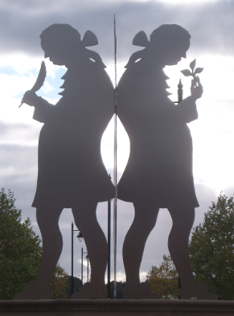Another of Dr Darwin’s interests was fossils: it was while studying fossils found locally that he started thinking about how different life forms came about. His ideas were developed and made famous by his grandson, Charles, in his theory of evolution.

Darwin’s imagination led him to all kinds of inventions from speaking machines to steering mechanisms for carriages: he noted down many of his ideas in a ‘commonplace book’ which is housed in the museum. In addition he wrote books and poetry on many subjects.

These are the items Erasmus is holding in the statue:

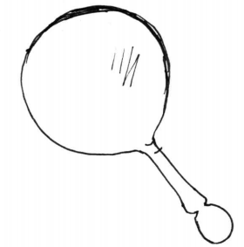 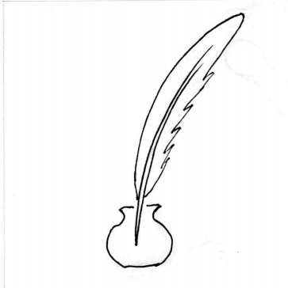 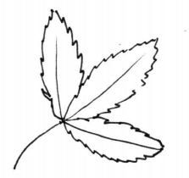 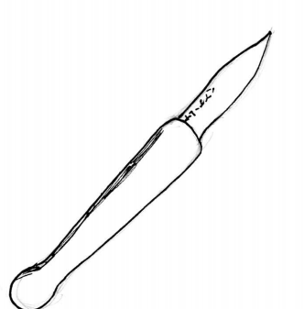

magnifying glass pen leaf scalpel

Can you think which of his activities each object refers to?

Do you have any special interests, hobbies or talents? If so, could you draw or describe an object that symbolises each one?

