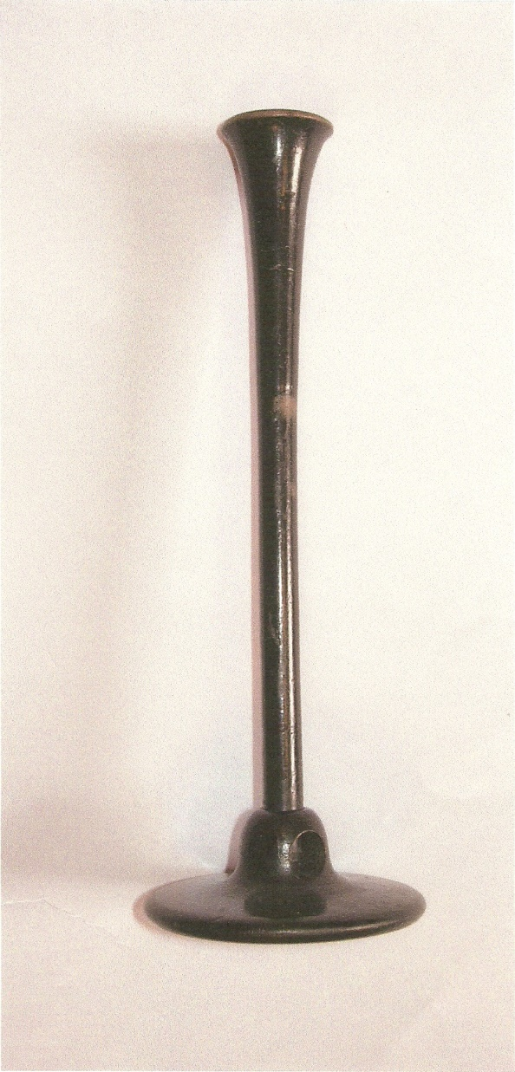 Newsletter 18/01/21

Can you guess what this is?

The second picture should give you a clue – it’s a stethoscope. A doctor uses a stethoscope to listen to sounds from a patient’s heart, lungs or blood vessels to check for any problems.

The old instrument (not a musical instrument!) in the picture dates from around 200 years ago. It is a wooden tube, one end of which would be placed on the patient’s chest and the other end held to the doctor’s ear. It is one of the many historical artefacts housed in the Erasmus Darwin museum.

Erasmus Darwin, as well as being a scientist, poet and inventor, was a physician (or doctor) who treated patients in the Lichfield area for 25 years from 1756. He may not have used this particular instrument, as it was invented a little later, but instead would have placed his ear directly onto his patient’s chest to listen.

In those days if you were ill you wouldn’t pop in to the GP surgery. You would send a message to the local physician such as Dr.Darwin, who would ride to your home on his horse, called Doctor. Depending on the diagnosis you might then be bled, have leeches applied to your skin, or be given medicine containing anything from frogspawn to pig’s dung.

Many doctors charged a large fee for his visit, and most ordinary people couldn’t afford to send for one if they were ill.

Examples of many items of medical apparatus from Darwin’s time are kept here at the museum. As soon as Covid restrictions are lifted you will be able to see them and even handle some of them.

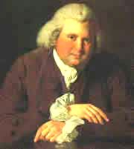We hope to see you then…meanwhile here’s a tongue-twister for you: “Seth says his stethoscope is the best stethoscope”. You can probably think of a better one!